Documentation for Scilab and GNU Octave Software Interfaces for NATS

IMPORTANT NOTE: These interfaces have been tested only with the specific versions of Scilab and GNU Octave identified in this document.

Instructions for Scilab:
1. Install Scilab by running "sudo apt-get install scilab". NATS currently supports Scilab version 6.0.0.
2. Run scilab by running "sudo scilab" command in terminal.
3. Open the provide sample file in Scilab window using:
"File→Open...../NATS_Client/sample/Scilab_SampleMonteCarlo…….._Beta_1.3.sce". On line 12 and 13, provide the location of NATS Client and NATS Server directories, respectively.
4. Start the NATS Server.
5. Click execute button (5th from right) on the toolbar in Scilab window.
6. Once Simulation is complete, the output should be present in NATS_Server/share/mcSimulation/, in the file “AIRCRAFT_CALLSIGN-Scilab-Monte-Carlo-Sim-Trajectory_INDEX.csv”. Also, output graphs such as the ones in the following will be generated:
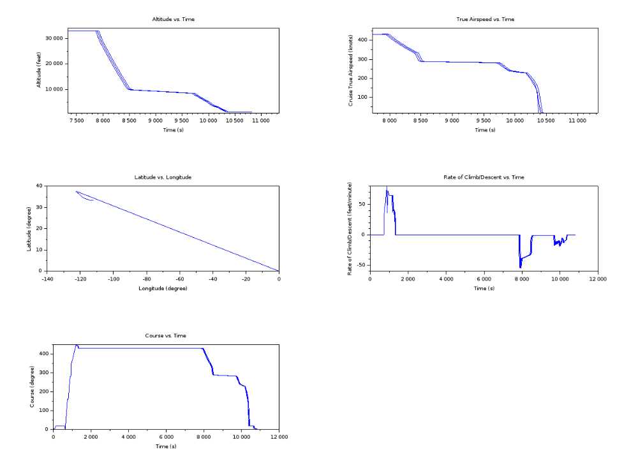

Instructions for using the GNU Octave Software Interface:

1. Install Octave by running "sudo apt-get install octave". NATS currently supports Octave version 4.2.x.
2. Run Octave by running "sudo octave" command in terminal.
3. Start NATS Server.
4. Go to NATS_Client directory in the terminal, and run "octave --persist sample/Octave_SampleMonteCarlo..._Beta_1.3.m". The “--persist” argument is to make sure the graphs generated do not close once the program is executed.
5. Once Simulation is complete, the output should be present in NATS_Server/share/mcSimulation/ folder, under the file name “AIRCRAFT_CALLSIGN-Octave-Monte-Carlo-Sim-Trajectory_INDEX.csv”. Also, the output graphs generated, as shown in the following:
